Here is the GitHub link <https://github.com/pmnguye3/JAMSGitHub.git>

You will need it to connect to GitHub.

Steps to connect to GitHub:

1. Start Visual Studios and click on the Team Viewer Tab.
2. Click on the Outlet icon.
3. Click on the Clone Button. 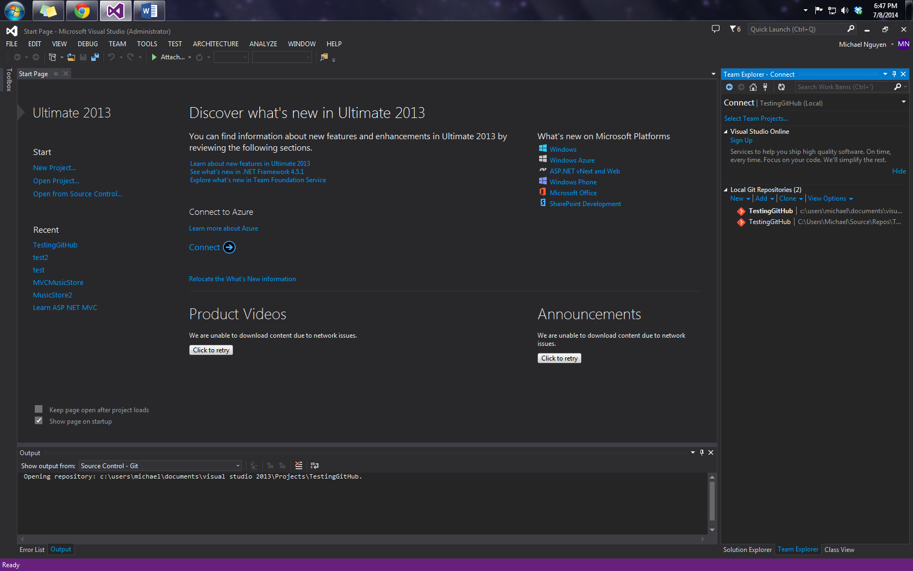

3

2

1

1. Now, paste in the GitHub Link from above, after that you click on clone.
2. Congrats! You now have the JAMS project from GitHub inside your Visual Studios.
3. To access that project, double click on the JAMSGitHub that you just cloned. Visual Studios should take you to another menu that shows you the JAMSv1.0.sln solution file.
4. Double click on the JAMSv1.0.sln solution file to access the project, and start coding.

How to Sync to GitHub:

1. After you make any edits to the code, your solution explorer will show an odd checkmark right next to the file name. 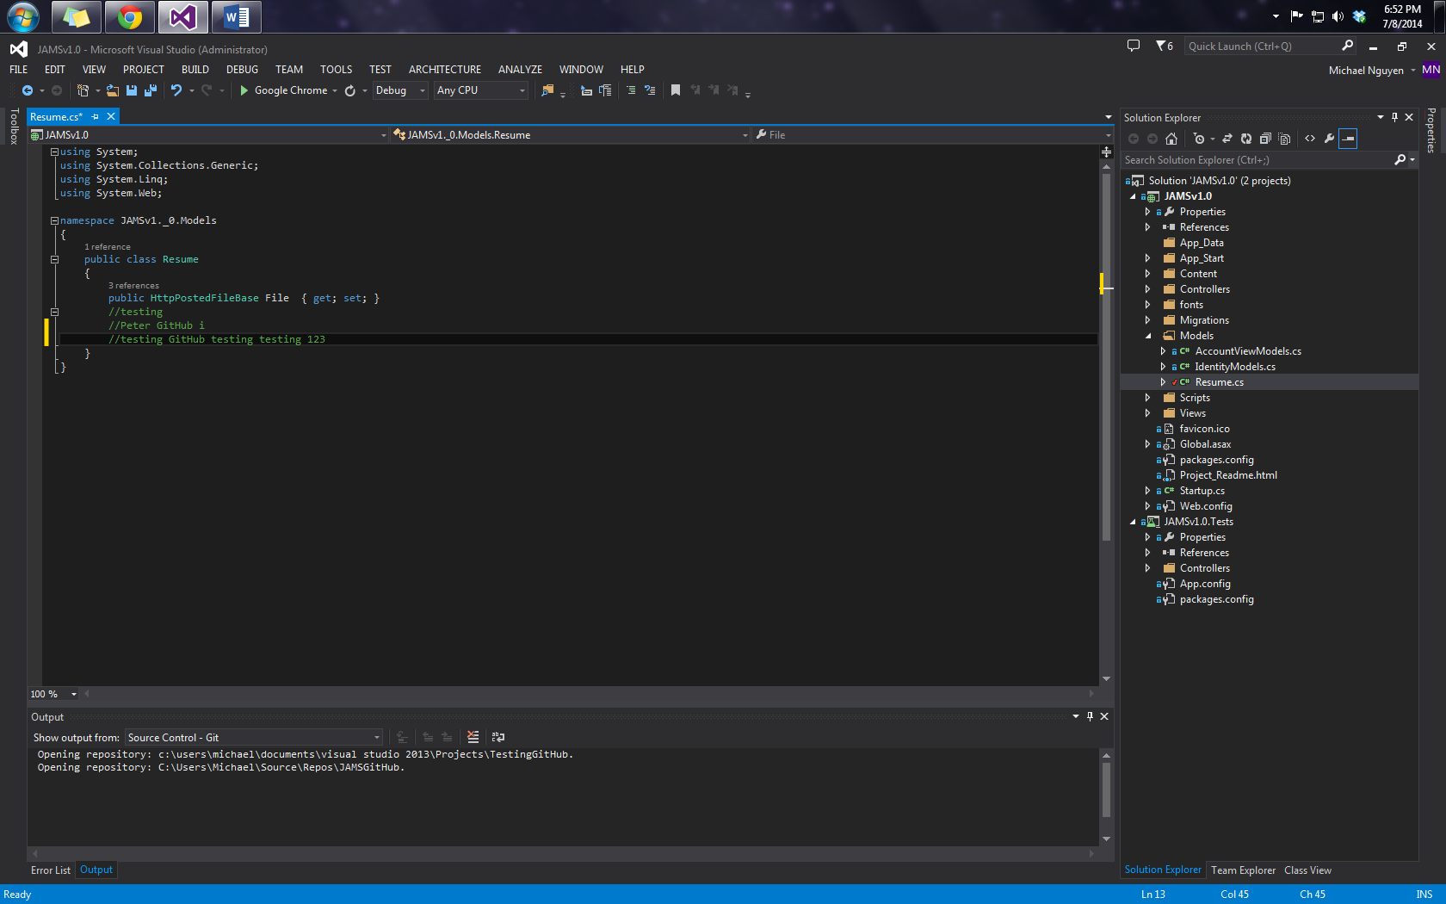

There’s that check mark.

New Code that I just typed

1. Right click on that file, and click “commit”. Commit in GitHub is basically you telling GitHub that these changes you want to show up on the project. 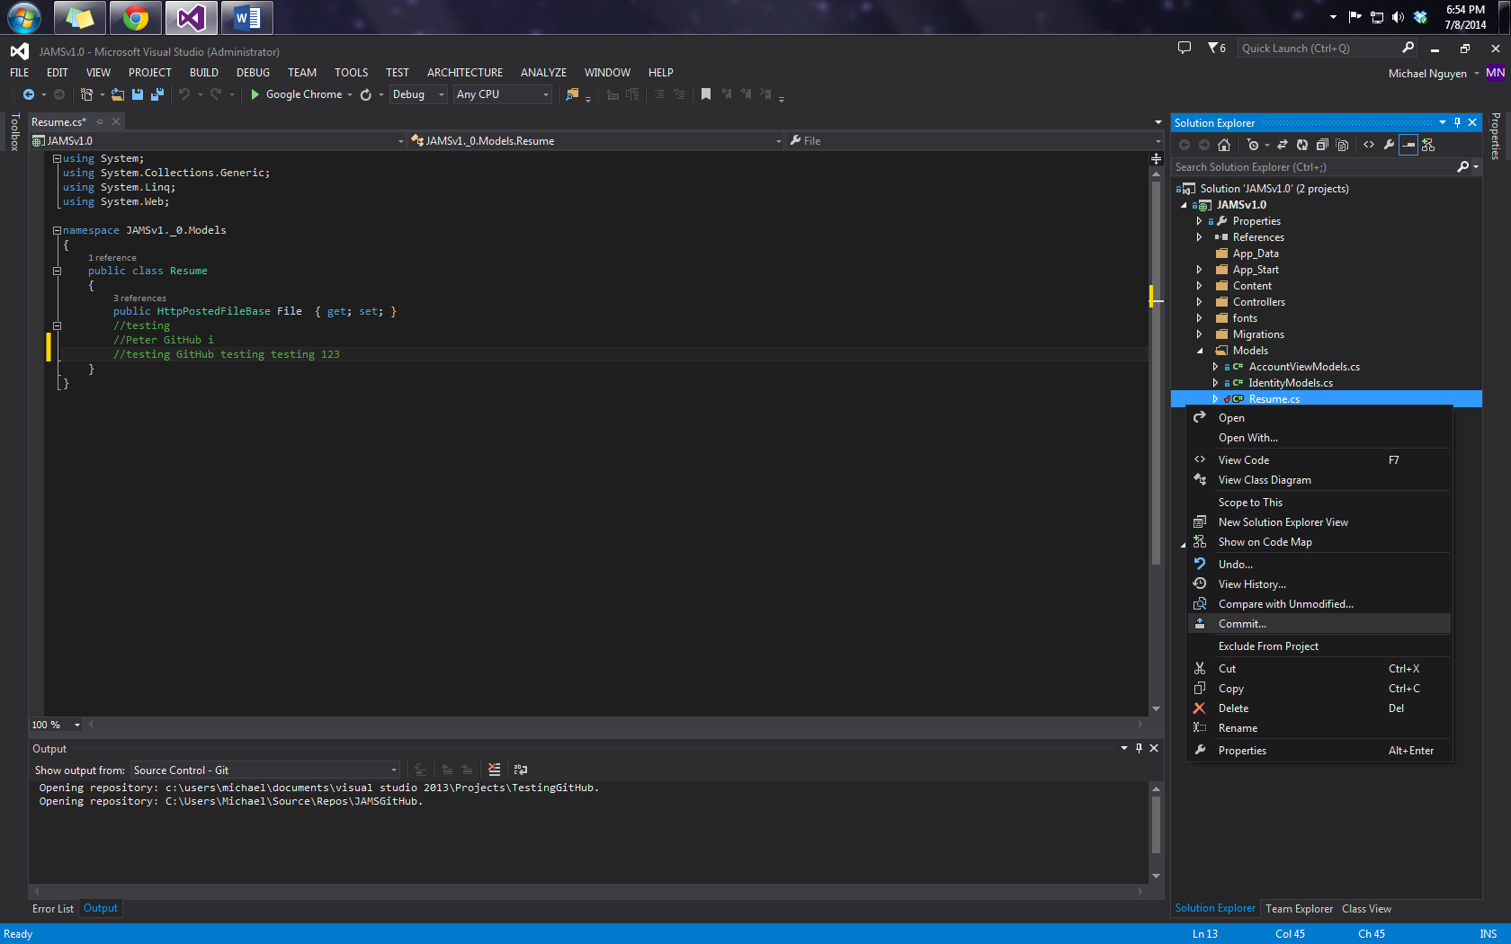
2. After click on commit, Visual Studio will take you to another menu and ask you to type some random message for the commit. Type what ever short description you have for the change, and click on Commit.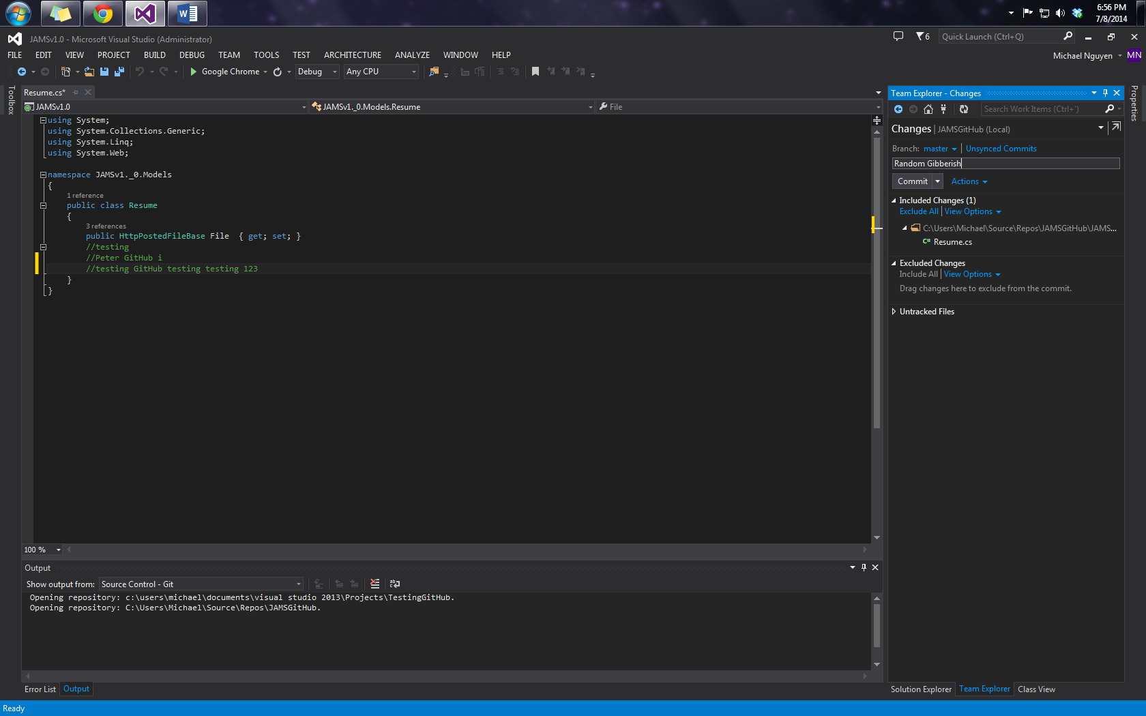
3. After committing, you have to Sync your changes to the GitHub server. The reason being is that GitHub is not centralized. We all have our own copies. So when we change things, we have to manually sync it to the server.  
   Click on the Home Icon on the Team Explorer Tab. Then Click on Unsynced Commits. Then click Sync. 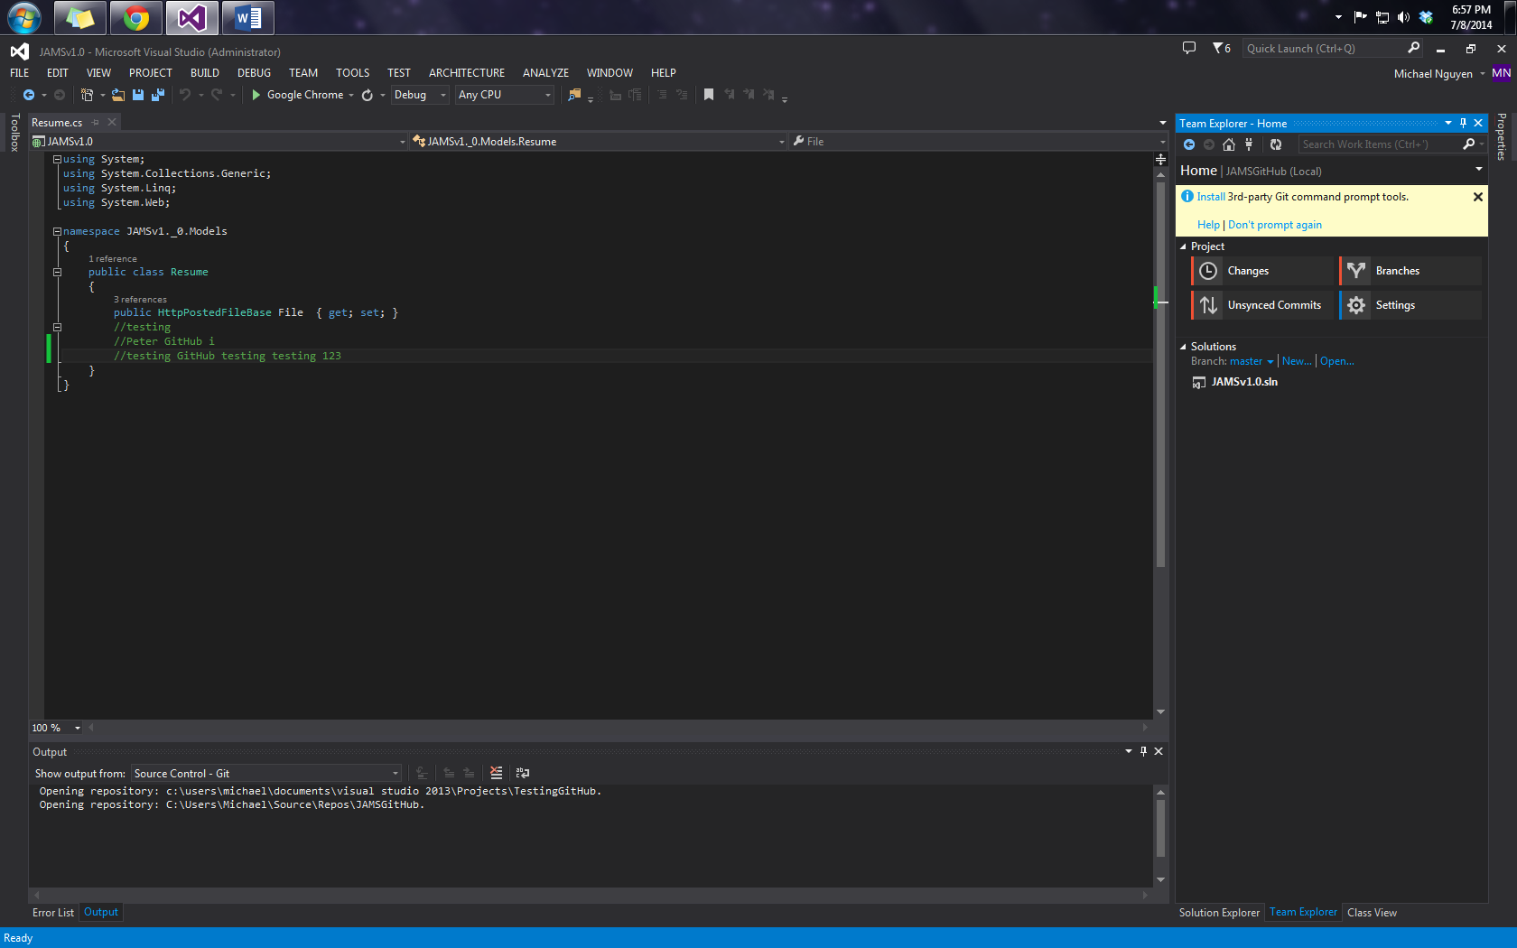

Home Icon

UnSynced Commits

1. It will ask you to entire your GitHub Username and Password. Enter it in, and it should sync.